**AND**

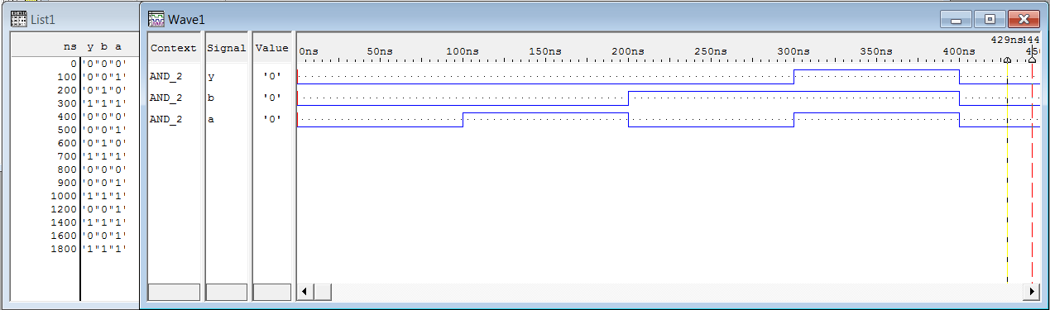

**OR**

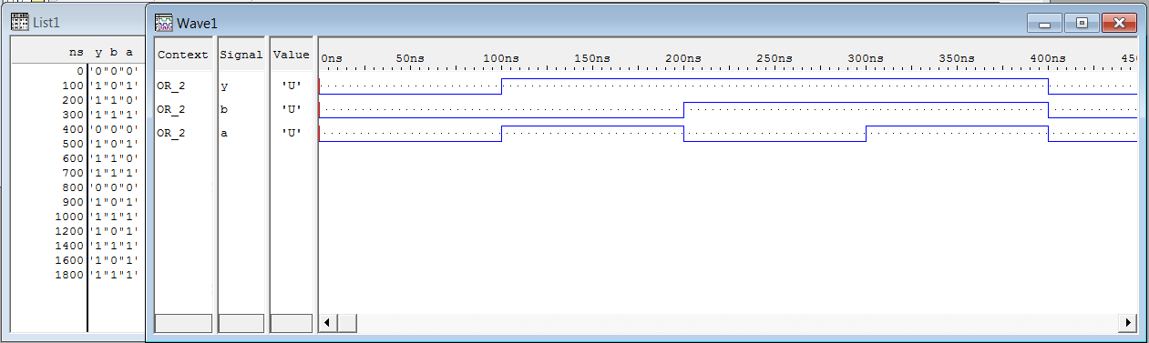

|  |  |
| --- | --- |
|  | **NOT** |
|  | **NAND** |
|  | **NOR** |
|  | **XOR** |

**XNOR**

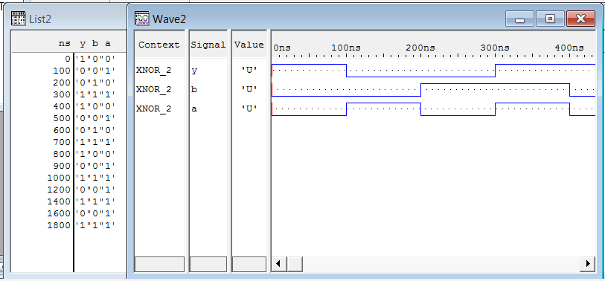

|  |  |
| --- | --- |
|  | **HALF ADDER** |
|  | **FULL ADDER** |