OUTPUT :

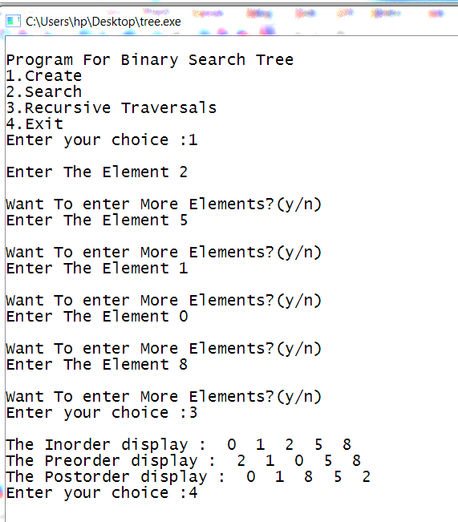

PROGRAM TO IMPLEMENT BINARY SEARCH TREE AND TREE TRAVERSALS

CODING:

# include <stdio.h>
# include <conio.h>
# include <stdlib.h>

typedef struct BST
{
int data;
struct BST *lchild,*rchild;
}node;

void insert(node *,node *);
void inorder(node *);
void preorder(node *);
void postorder(node *);
node *search(node *,int,node **);

int main()
{
int choice;
char ans='N';
int key;
node *new_node,*root,*tmp,*parent;
node *get_node();
root=NULL;

printf("\nProgram For Binary Search Tree ");
printf("\n1.Create");
printf("\n2.Search");
printf("\n3.Recursive Traversals");
printf("\n4.Exit");
do
{
printf("\nEnter your choice :");
scanf("%d",&choice);

switch(choice)
{
case 1:
do
{
new_node=get_node();

printf("\nEnter The Element ");
scanf("%d",&new_node->data);

if(root==NULL) /* Tree is not Created */
root=new_node;
else
insert(root,new_node);

printf("\nWant To enter More Elements?(y/n)");
ans=getch();

}while(ans=='y');

break;

case 2:
printf("\nEnter Element to be searched :");
scanf("%d",&key);

tmp = search(root,key,&parent);

printf("\nParent of node %d is %d",
tmp->data,parent->data);
break;

case 3:

if(root==NULL)
printf("Tree Is Not Created");
else
{
printf("\nThe Inorder display : ");
inorder(root);
printf("\nThe Preorder display : ");
preorder(root);
printf("\nThe Postorder display : ");
postorder(root);
}

break;
}
}while(choice!=4);
getch();
return 0;
}
/*
Get new Node
*/
node *get_node()
{
node *temp;
temp=(node *)malloc(sizeof(node));
temp->lchild=NULL;
temp->rchild=NULL;
return temp;
}
/*
This function is for creating a binary search tree
*/
void insert(node *root,node *new_node)
{
if(new_node->data < root->data)
{
if(root->lchild==NULL)
root->lchild = new_node;
else
insert(root->lchild,new_node);
}

if(new_node->data > root->data)
{
if(root->rchild==NULL)
root->rchild=new_node;
else
insert(root->rchild,new_node);
}
}
/*
This function is for searching the node from
binary Search Tree
*/
node *search(node *root,int key,node **parent)
{
node *temp;
temp=root;
while(temp!=NULL)
{
if(temp->data==key)
{
printf("\n The %d Element is Present",temp->data);
return temp;
}
*parent=temp;

if(temp->data>key)
temp=temp->lchild;
else
temp=temp->rchild;
}
return NULL;
}
/*
This function displays the tree in inorder fashion
*/
void inorder(node *temp)
{
if(temp!=NULL)
{
inorder(temp->lchild);
printf(" %d ",temp->data);
inorder(temp->rchild);
}
}
/*
This function displays the tree in preorder fashion
*/
void preorder(node *temp)
{
if(temp!=NULL)
{
printf(" %d ",temp->data);
preorder(temp->lchild);
preorder(temp->rchild);
}
}

/*
This function displays the tree in postorder fashion
*/
void postorder(node *temp)
{
if(temp!=NULL)
{
postorder(temp->lchild);
postorder(temp->rchild);
printf(" %d ",temp->data);
}
}

