- PROGRAM TO IMPLEMENT STACK IN ARRAY

#include<stdio.h>
#include<conio.h>
#include<process.h>
int stack[10];
static int top=-1;
void push()
{
if(top==9)
{
printf("\nOVERFLOW");
exit(0);
}
else
{
top++;
printf("\nenter the element: ");
scanf("%d",&stack[top]);
}
}
void pop()
{
if(top==-1)
{
printf("UNDERFLOW");
exit(0);
}
else
{
printf("The deleted element is: %d ",stack[top]);
stack[top]=NULL;
top--;
}
}
main()
{
clrscr();
int ch;
int cha=1;
int chaa=1;
printf("\n1.Push an element\n2.Pop an element\n3.Display\n4.Exit");
while(1)
{
printf("\nEnter your choice from MENU:");
scanf("%d",&ch);
switch(ch)
{
case 1:while(cha==1)
{
push();
printf("do you wish to continue?(1/0):");
scanf("%d",&cha);
}
break;
case 2: while(chaa==1)
{
pop();
printf("do you wish to continue?(1/0):");
scanf("%d",&chaa);
}
break;

case 3: printf("\nThe STACK is:\n");
for(int i=top;i>=0;i--)
{
printf("\n%d",stack[i]);
}
break;
case 4: exit(0);
}
getch();
}
}

OUTPUT:

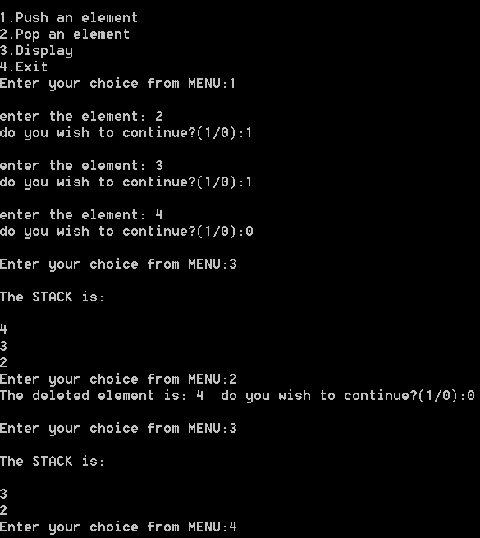
- PROGRAM TO IMPLEMENT QUEUE IN ARRAY

# include <stdio.h>
#include<conio.h>
#include<process.h>
# define SIZE 10

int arr[ SIZE ], front = -1, rear = -1, i ;
void enqueue() ;
void dequeue() ;
void display() ;

int main()
{
int ch,ch1=1 ;
int ch2=1;
clrscr();
printf("\n\tMENU\n[1].ENQUEUE\n[2].DEQUEUE\n[3].Display\n[4].Exit\n") ;
do
{
printf( "Enter your choice from MENU [1-4] : " ) ;
scanf( "%d", &ch ) ;

switch ( ch )
{
case 1 :while(ch1==1)
{
enqueue() ;
printf("\nWant to enter more...(1/0)");
scanf("%d",&ch1);
}
break ;

case 2 :while(ch2==1)
{
dequeue() ;
printf("\nWant to enter more...(1/0)");
scanf("%d",&ch2);
}
break ;

case 3 : display() ;
break ;

case 4 : exit(0);

default : printf( "Invalid option\n" ) ;
}
}
while ( ch != 4 ) ;
return 0;
}

void enqueue()
{
if ( rear == SIZE)
{
printf( "Queue is full (overflow)\n" ) ;
return ;
}
rear++ ;
printf( "Enter the element to ENQUEUE : " ) ;
scanf( "%d", &arr[ rear ] ) ;
if ( front == -1 )
front++ ;
}

void dequeue()
{
if ( front == -1 )
{
printf( "Queue is empty (underflow)\n" );
return ;
}
printf( "The DEQUEUE element is : %d\n", arr[ front ] ) ;
if ( front == rear )
front = rear = -1 ;
else
front++ ;
}

void display()
{
if ( front == -1 )
{
printf( "Queue is empty (underflow)\n" ) ;
return ;
}
printf( "The elements in queue are : FRONT -> " ) ;

for ( i = front ; i <= rear ; i++ )
printf( "%d<-", arr[ i ] ) ;

printf( "REAR\n" ) ;
}

OUTPUT:
