/** PROGRAM TO FIND SUM,DIFFERENCE,PRODUCT & REMAINDER OF TWO NUMBERS */

#include<stdio.h>

#include<conio.h>

void main()

{

float a,b,sum,mul,sub,div;

printf("enter the value of a and b: ");

scanf("%f%f",&a,&b);

sum=a+b;

mul=a*b;

sub=a-b;

div=a/b;

printf("sum of a and b is: %f",sum);

printf("\nsubstraction of a and b is: %f",sub);

printf("\nproduct of a and b is: %f",mul);

printf("\ndivision of a and b is: %f",div);

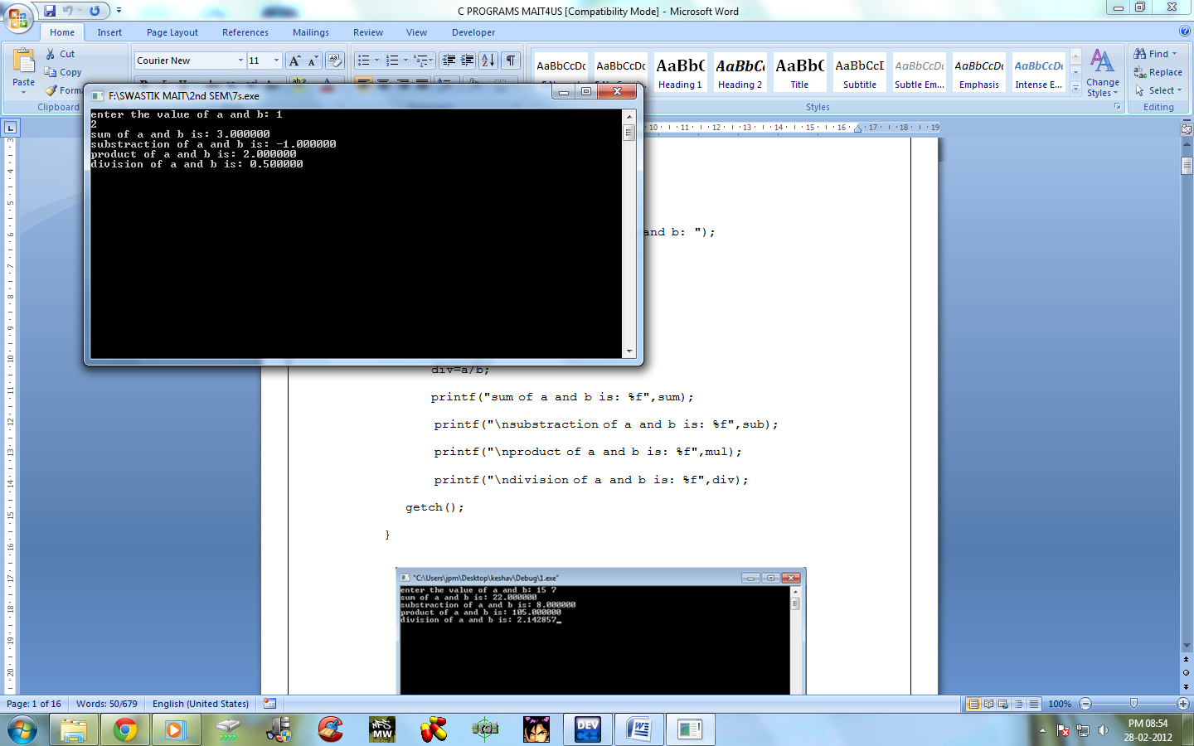
getch();

}

/**program using the formula (ax+b)/(ax-b)**/
#include<stdio.h>
#include<conio.h>
void main()
{
float a,x,b,formula;
printf("ENTER A NO.");
scanf("%f",&a);
printf("\nENTER ANOTHER NO.");
scanf("%f",&x);
printf("\nENTER ANOTHER NO.");
scanf("%f",&b);
formula=(a*x+b)/(a*x-b);
printf("\nans=%f",formula);
getch();
}
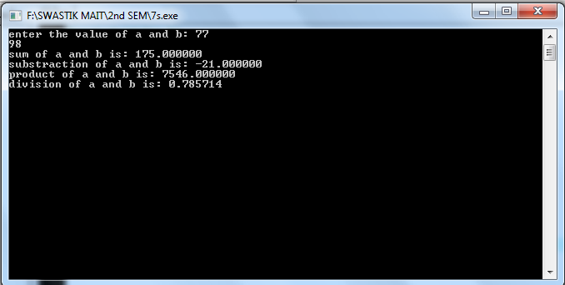
#include<stdio.h>
#include<conio.h>
void main()
{
int a;
printf("enter a no. btw 0-4\n");
scanf("%d",&a);
if(a<4)
{
if(1<a&&a<3)
{
printf("\nno. is 2");
}
else
{
printf("no.is either 1 or 3");
}
}
else
{
if(4<a&&a<6)
{
printf("\nno.is 5");
}
else
{
printf("no. is 3");
}
}
getch();
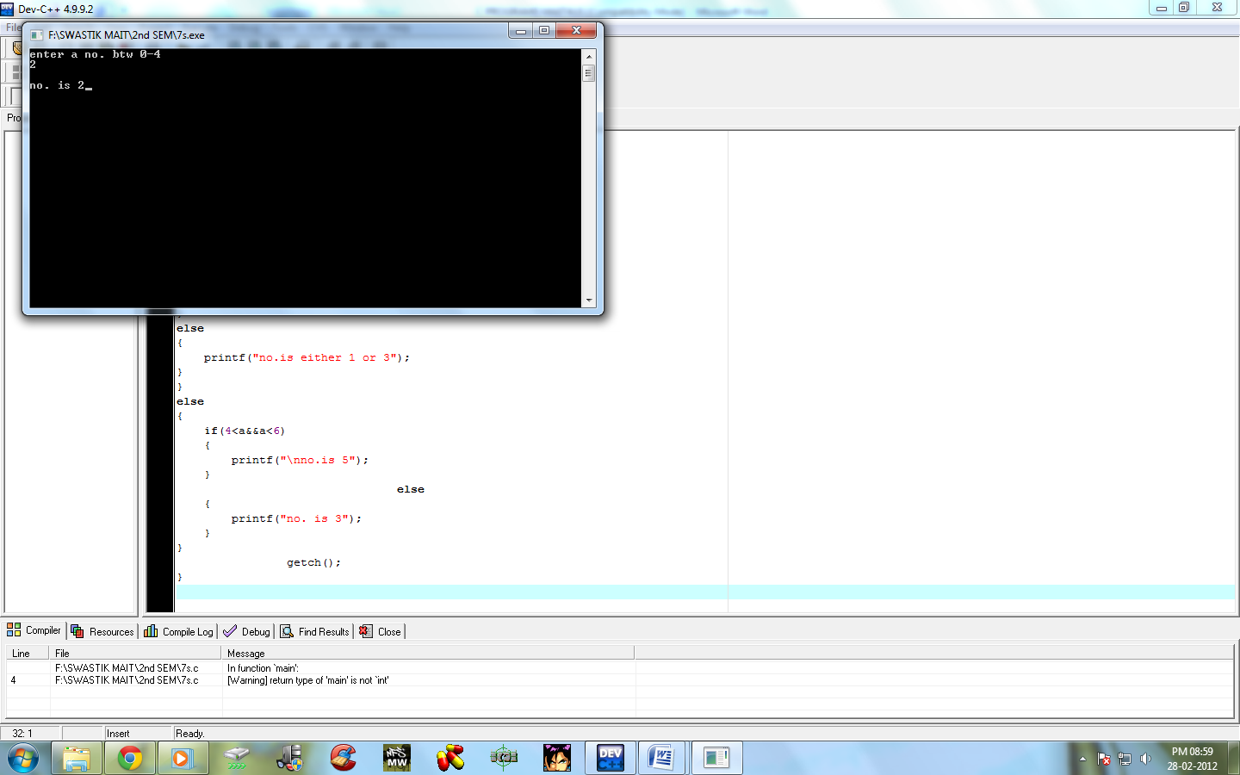
}

/***** PROGRAM TO PRINT WEEKDAYS USING SWITCH CASE *****/

#include<stdio.h>
#include<conio.h>
void main()
{
int n;
clrscr();
printf("Enter number between 1-7: ");
scanf("%d",&n);
switch(n)
{
case 1: printf("\nThe day is SUNDAY");
break;
case 2: printf("\nThe day is MONDAY");
break;
case 3: printf("\nThe day is TUESDAY");
break;
case 4: printf("\nThe day is WEDNESDAY");
break;
case 5: printf("\nThe day is THRUSDAY");
break;
case 6: printf("\nThe day is FRIDAY");
break;
case 7: printf("\nThe day is SATURDAY");
break;
default:printf("\nEnter a choice between 1 to 7");
break;
}
getch();
}
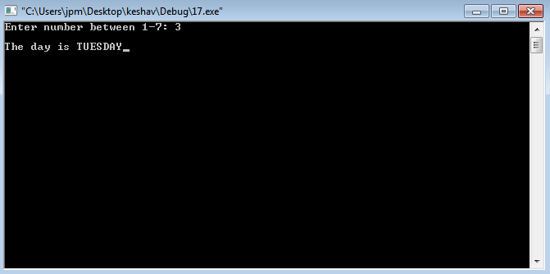
/*** program to show working of conditional operator ***/
/*******************************************************/

#include<stdio.h>

#include<conio.h>

void main()

{

int n;

clrscr();

printf("Enter a number: ");

scanf("%d",&n);

(n%2==0)?printf("\nIt is a even number"):printf("\nIt is an odd number");

getch();

}
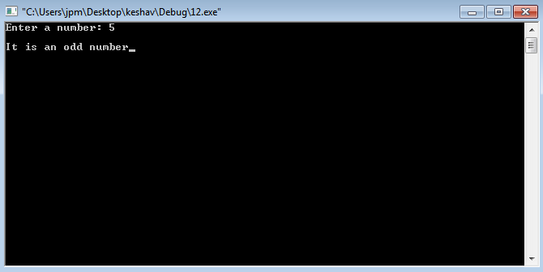

\**program using a formula***/
#include<stdio.h>
#include<conio.h>
#include<math.h>
void main()
{
float x,y,a,formula;
printf("enter a x value");
scanf("%f",&x);
printf("\nenter a y value");
scanf("%f",&y);
printf("\nenter a a value");
scanf("%f",&a);
formula=2.5*log(x)-cos(a)+(pow(x,2)-pow(y,2))+sqrt(2*x*y);
printf("\nans is =%f",formula);
getch();
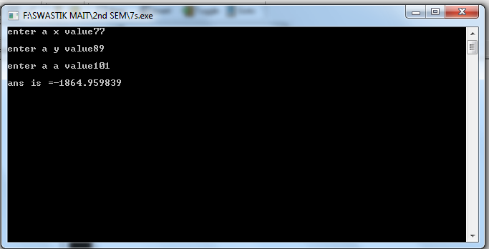
}

\**PROGRAM USING THE FORMULA**/
#include<stdio.h>
#include<conio.h>
#include<math.h>
void main()
{
float x,formula;
printf("ENTER ANY X VALUE:");
scanf("%f",&x);
formula=pow(x,5)+10*pow(x,4)+8*pow(x,3)+4*x+2;
printf("\nANS USING THE FORMULA=%f",formula);
getch();
}
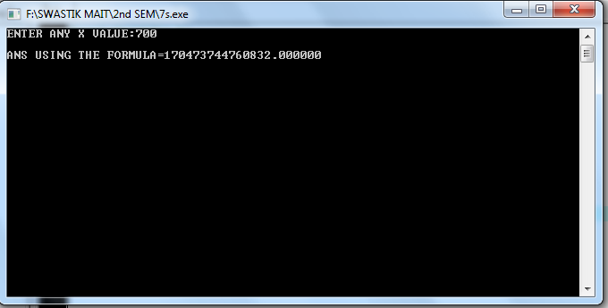

**\Write a program to find factorial of a given number**/

#include<stdio.h>
#include<conio.h>
void main()
{
int a,fact,i;
printf("ENTER ANY NO.\n");
scanf("%d",&a);
fact=1;
for(i=a;i>0;i--)
{
fact=fact*i;
}
printf("\nresult is=%d",fact);
getch();
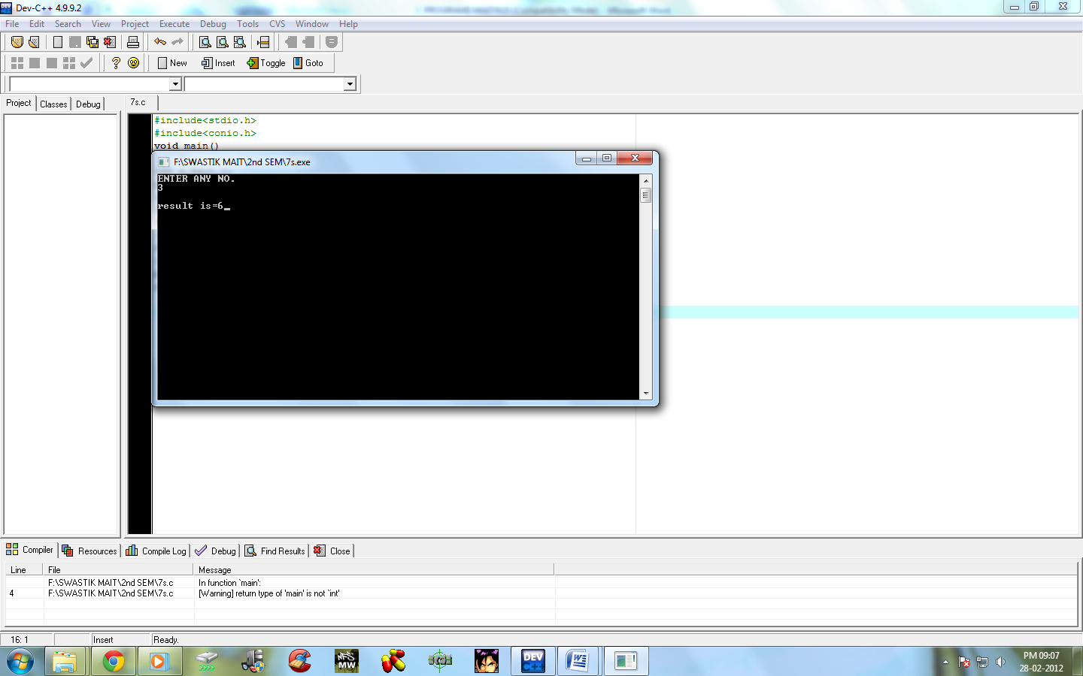
}

**\ Write a program to find sum of a geometric series**/

#include<stdio.h>
#include<conio.h>
#include<math.h>
void main()
{
int a,r,n,rest,formula;
printf("ENTER THE VALUE OF INITIAL\n");
scanf("%d",&a);
printf("ENTER THE VALUE OF COMMON RATIO\n");
scanf("%d",&r);
printf("ENTER THE NO. OF TERMS\n");
scanf("%d",&n);
formula=(a*(pow(r,n)-1))/(r-1);
printf("\nSUM OF A G.P IS =%d",formula);
getch();
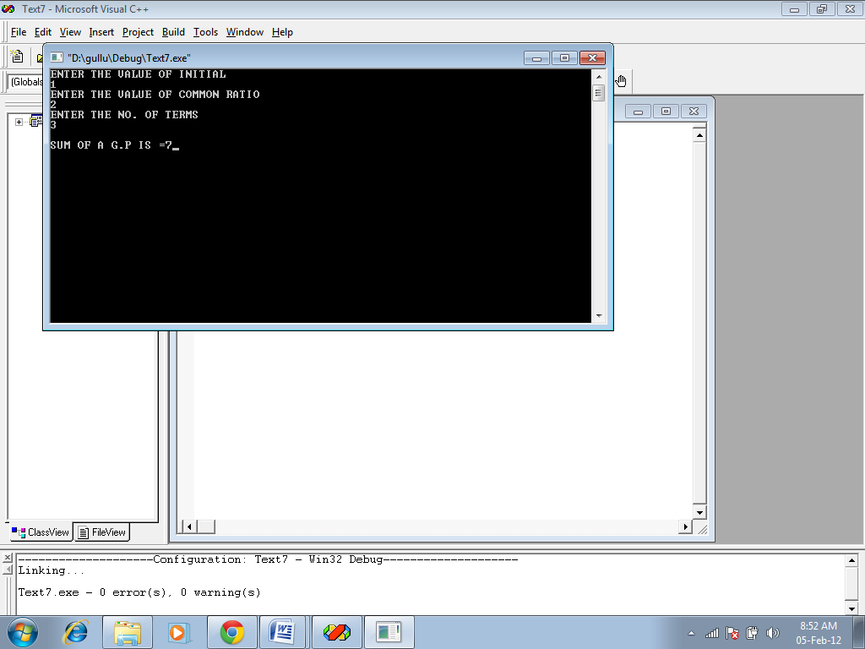
}

\**TO MAKE A CALCULATOR**/

#include<stdio.h>
#include<conio.h>
#include<math.h>
int main()
{
int a,b,c,d;
printf("Enter the no.s");
scanf("%d%d",&a,&b);
printf("enter \n1 for add, \n2 for subtract, \n3 for multiply, \n4 for divide");
scanf("%d",&d);
switch(d)
{
case 1:
c=a+b;
break;
case 2:
c=a-b;
break;
case 3:
c=a*b;
break;
case 4:
c=a/b;
break;
default:
printf("wrong choice");
}
printf("result=%d",c);
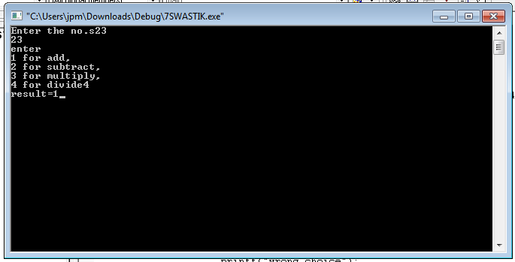
getch();
return 0;
}

\** PROGRAME TO CONVERT LOWER CASE TO UPPERCASE**/

#include<stdio.h>
#include<conio.h>
int main()
{
char ch,ab;
printf("enter any alphabet ");
scanf("%c",&ch);
if(ch>96&&ch<123)
{
ab=ch-32;
printf("uppercase=%c",ab);}
else
{
printf("already in uppercase");}
getch();
return(0);
}

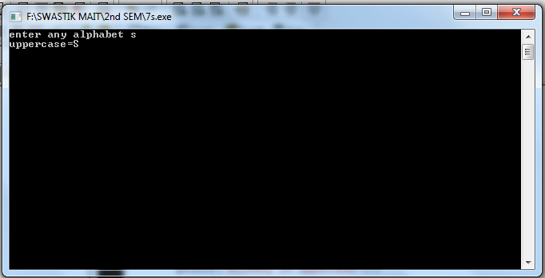

\** PROGRAME TO CONVERT LOWERCASE TO UPPERCASE**/

#include<stdio.h>
#include<conio.h>
int main()
{
char ch,ab;
printf("enter any alphabet ");
scanf("%c",&ch);
if(ch>64&&ch<91)
{
ab=ch+32;
printf("lowercase=%c",ab);
}
else
{
printf("already in lowercase");
}
getch();
return(0);
}

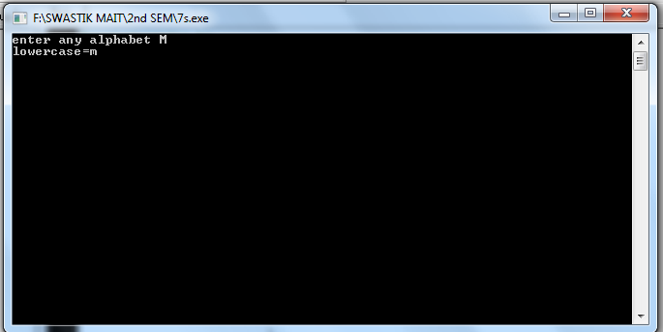

\** PROGRAME TO WRITE NO. IN WORDS**/

#include<stdio.h>
#include<conio.h>
int main()
{
int a;
printf("enter any digit btw 0-9\n");
scanf("%d",&a);
switch(a)
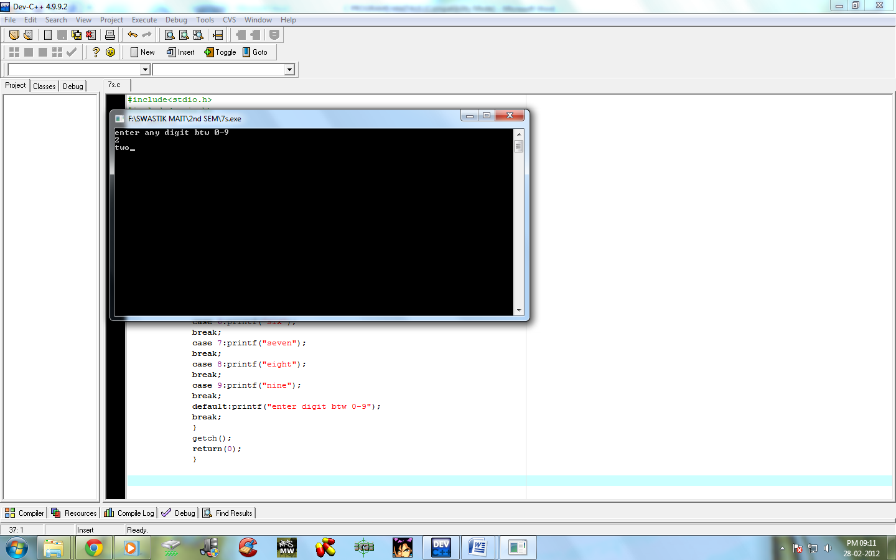
{
case 0:printf("zero");
break;
case 1:printf("0ne");
break;
case 2:printf("two");
break;
case 3:printf("three");
break;
case 4:printf("four");
break;
case 5:printf("five");
break;
case 6:printf("six");
break;
case 7:printf("seven");
break;
case 8:printf("eight");
break;
case 9:printf("nine");
break;
default:printf("enter digit btw 0-9");
break;
}
getch();
return(0);
}

\** PROGRAME TO CHECK WEATHER THE TRIANGLE IS POSSIBLE OR NOT**/

#include<stdio.h>
#include<conio.h>
int main()
{
float x,y,z;
printf("enter three sides of triangle\n");
scanf("%f%f%f",&x,&y,&z);
if(x>y&&x>z)
{
if((y+z)>x)
printf("\ntriangle is possible");
else
printf("\ntriangle is not possible");
}
else if(y>x&&y>z)
{
if((x+z)>y)
printf("\ntriangle is posiible");
else
printf("\ntriangle is not possible");}
else if(z>x&&z>y)
{
if((x+y)>z)
printf("\ntriangle is possible");
else
printf("\ntriangle is not possible");}
getch();
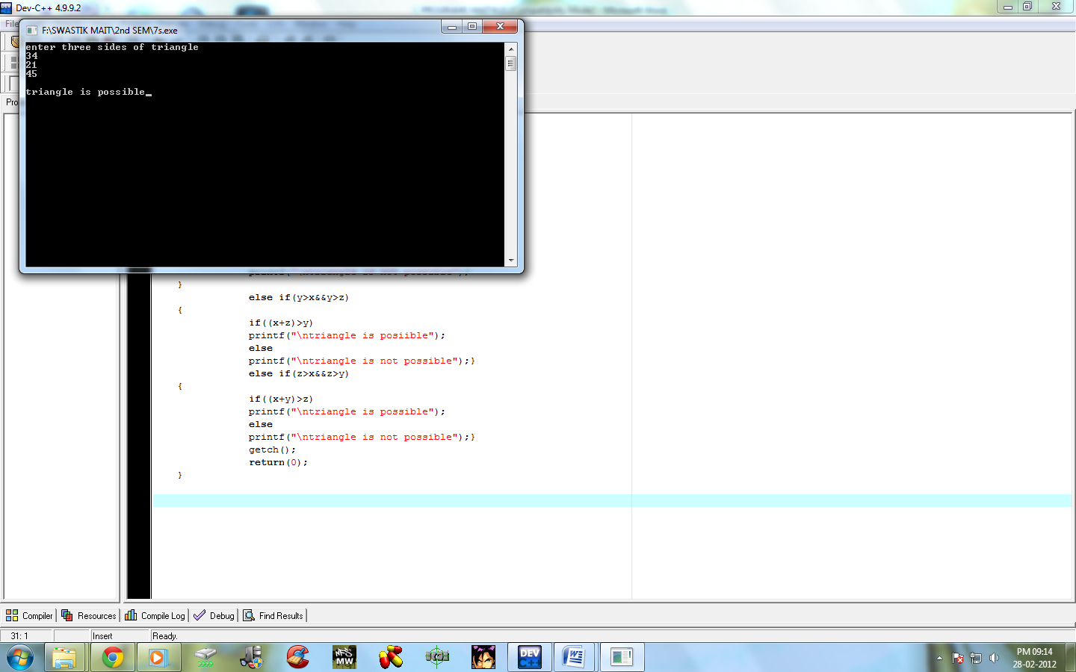
return(0);
}

\** PATTERN PROGRAM**/

#include<stdio.h>
#include<conio.h>
int main()
{
int i,j;
for(i=1;i<5;i++)
{

for(j=1;j<=i;j++)
{
printf("%d ",i);
}
printf("\n");
}
getch();
return(0);
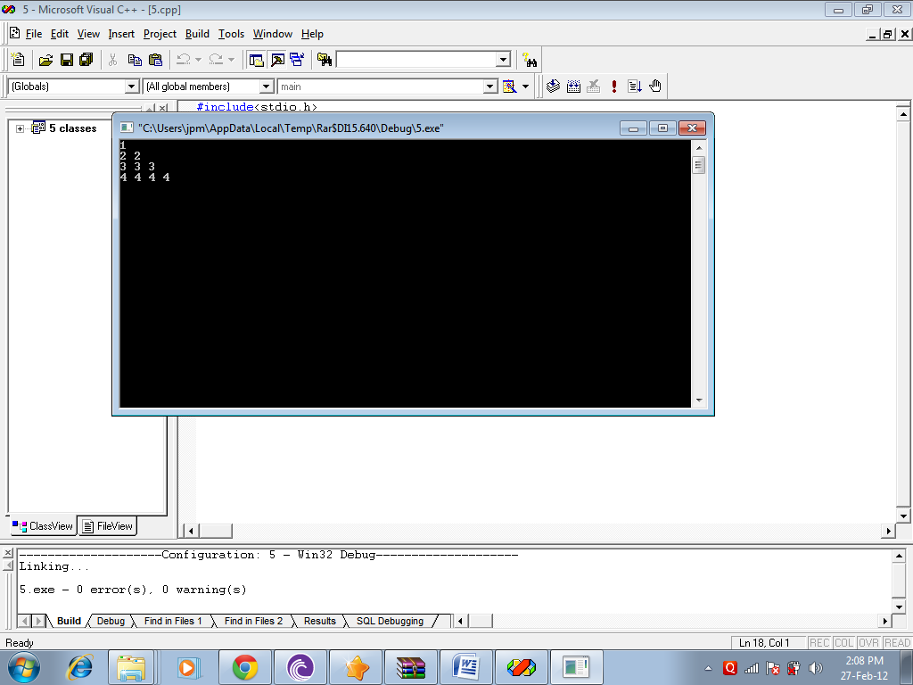
}

\** PATTERN PROGRAM**/

#include<stdio.h>
#include<conio.h>
int main()
{
int i,j;
for(i=1;i<5;i++)
{

for(j=1;j<=i;j++)
{
printf("%d ",j);
}
printf("\n");
}
getch();
return(0);
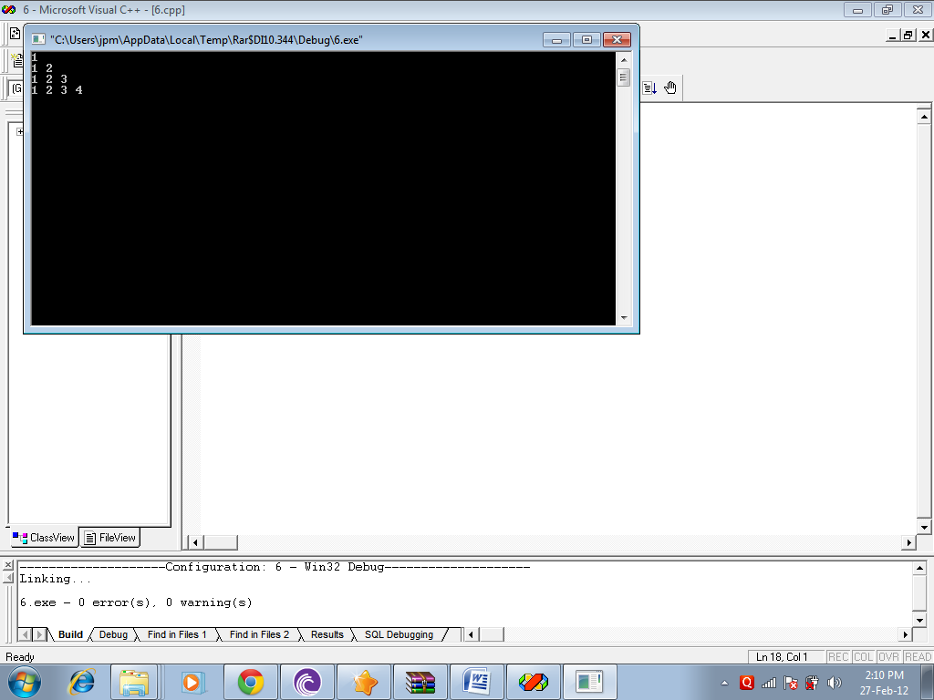
}

#include<stdio.h>
#include<conio.h>
main()
{
int a,b,c,d,p,q;
printf("Enter first complex number (first real and then imaginary part:");
scanf("%d",&a);
scanf("%d",&b);
printf("Ist complex number:%d+%di",a,b);
printf("Enter second complex number (first real and then imaginary part:");
scanf("%d",&c);
scanf("%d",&d);
printf("IInd complex number:%d+%di",c,d);
p=a*c-b*d;
q=a*d+b*c;
printf("\nProduct:%d+%di",p,q);
getch();
}
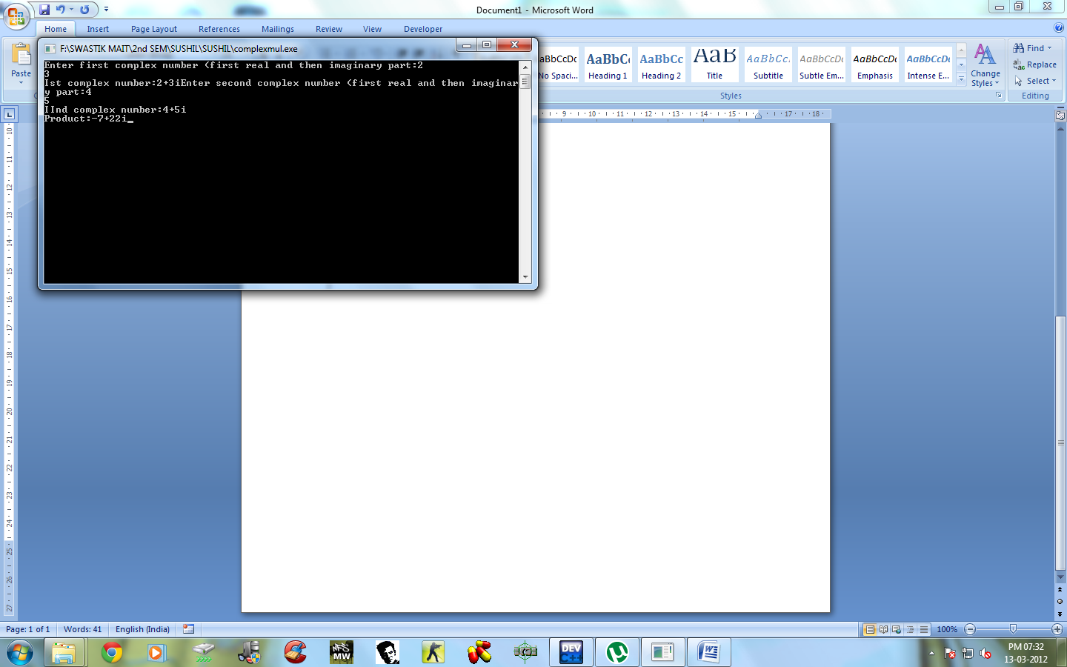

#include<stdio.h>
#include<conio.h>
int main()
{
int i,j,k;
for(i=1;i<=5;i++)
{

for(k=5;k>=i;k--)
{
printf(" ");
}
for(j=1;j<=i;j++)
{

printf("%d ",i);
}
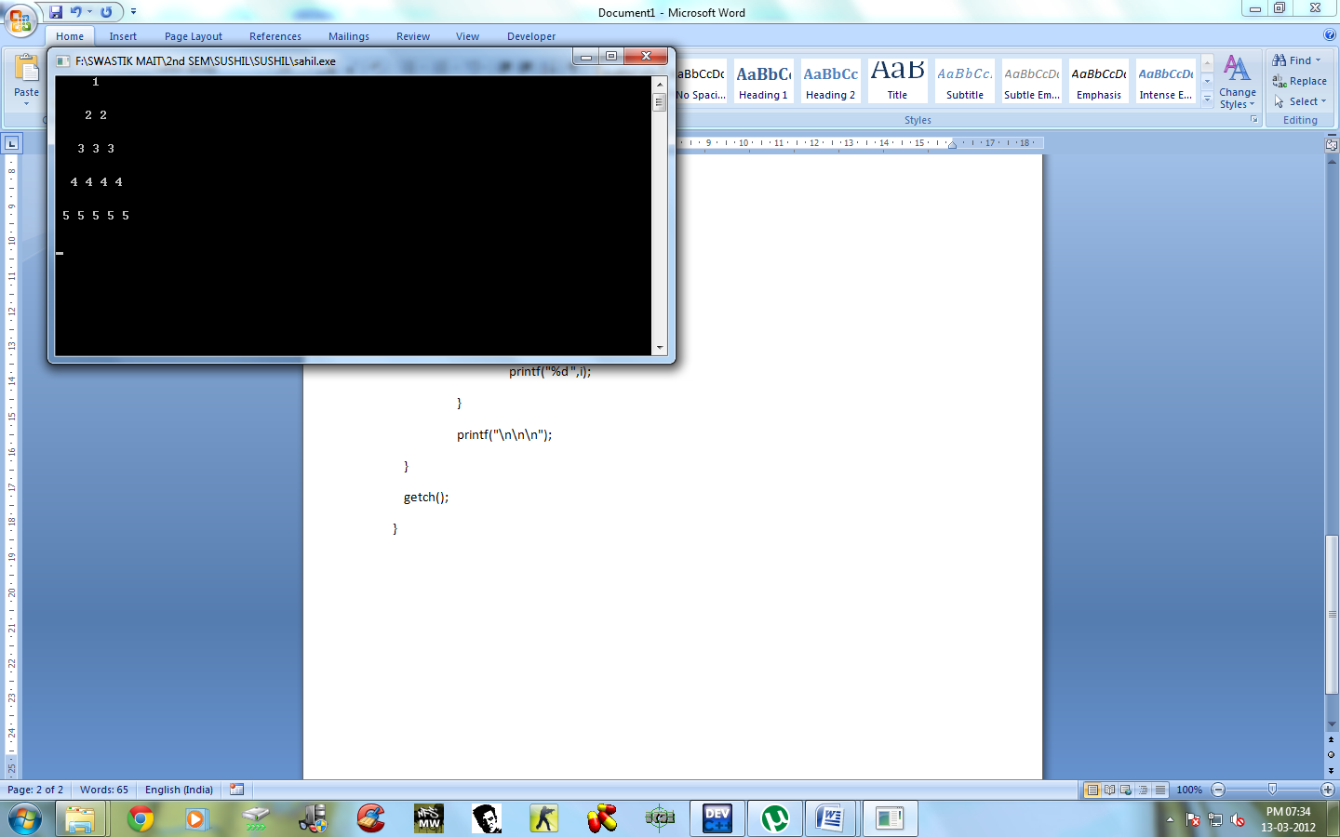
printf("\n\n\n");
}
getch();
}

#include<stdio.h>
#include<conio.h>
main()
{
int a[3][3],b[3][3],c[3][3];
int i,j,k;
printf("Enter matrix A\n");
for(i=0;i<3;i++)
{
for(j=0;j<3;j++)
{
scanf("%d",&a[i][j]);
}
}
for(i=0;i<3;i++)
{
for(j=0;j<3;j++)
{
b[i][j]=a[j][i];
}
}
printf("matrix A\n");
for(i=0;i<3;i++)
{ printf("\n");
for(j=0;j<3;j++)
{
printf("%d\t",a[i][j]);
}
}
printf("\n Transpose of matrix A\n");
for(i=0;i<3;i++)
{ printf("\n");
for(j=0;j<3;j++)
{
printf("%d\t",b[i][j]);
}
}
getch();
}
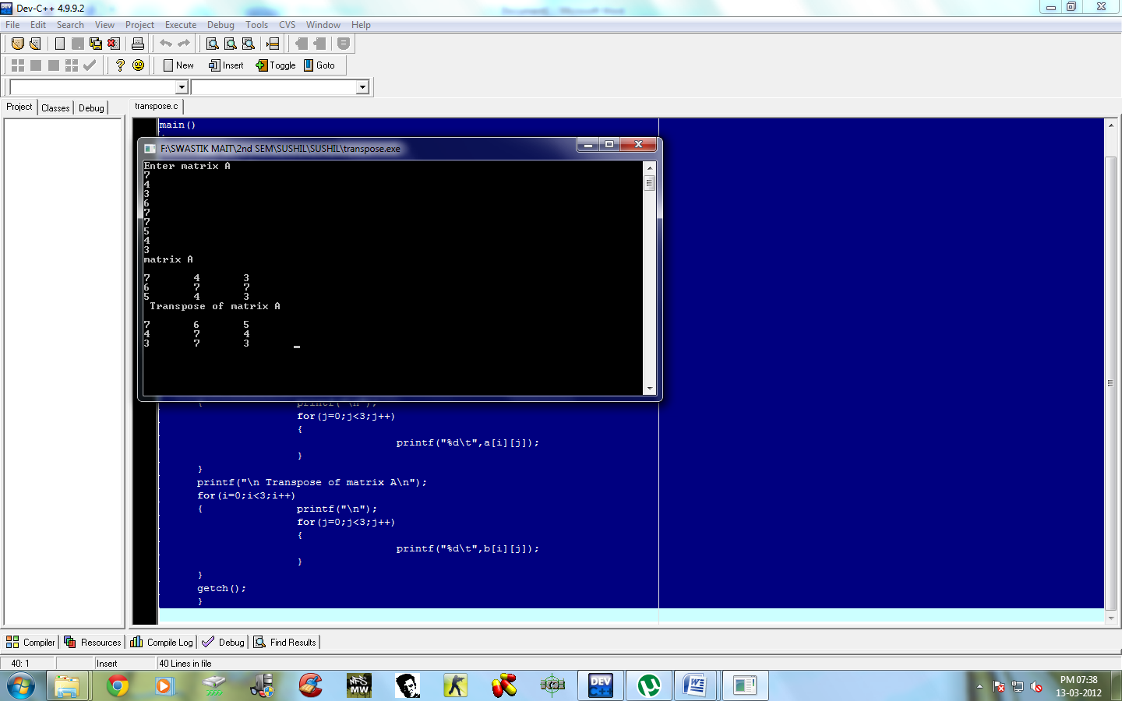

#include<stdio.h>
#include<conio.h>
int main()
{
int i,j,k,a[10][10],b[10][10],c[10][10];
int n=3;
for(i=0;i<n;i++)
{
for(j=0;j<n;j++)
{printf("enter the value of a[%d][%d]",i,j);
scanf("%d",&a[i][j]);
}
}
for(i=0;i<n;i++)
{
for(j=0;j<n;j++)
{
printf("enter the value of b[%d][%d]",i,j);
scanf("%d",&b[i][j]);
}
}
for(i=0;i<n;i++)
{
for(j=0;j<n;j++)
{ c[i][j]=0;
for(k=0;k<n;k++)
{
c[i][j]+=a[i][k]*b[k][j];
}
}}
for(i=0;i<n;i++)
{
for(j=0;j<n;j++)
{printf("%d ",c[i][j]);

}
printf("\n\n");
}
getch();
return(0);
}
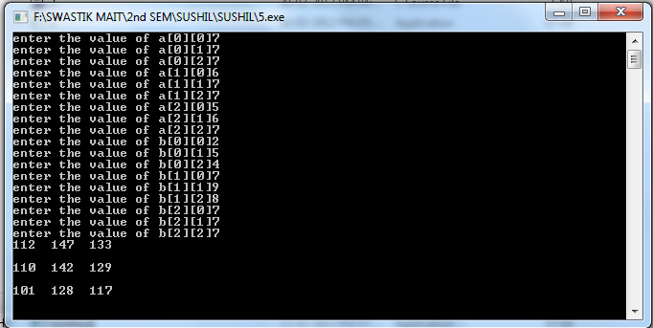

PROGRAM TO CALCULATE NUMBER OF WORDS, CHARACTERS, VOWELS AND SPACES IN THE STRING

#include<conio.h>
#include<stdio.h>
main()
{
Char str[25];
Int i,l,w=0,v=0,c=0,s=0;
printf("Enter the string:\n");
gets(str);
l=strlen(str);
printf("%d",l);
for(i=0;i<l;i++)
{
if(str[i]==' ')
s++;
else if((str[i]=='a'||'e'||'i'||'o'||'u'))
v++;
}
w=s+1;
c=l-s;
printf("\nIn entered string, there are %d words, %d characters, %d vowels and %d
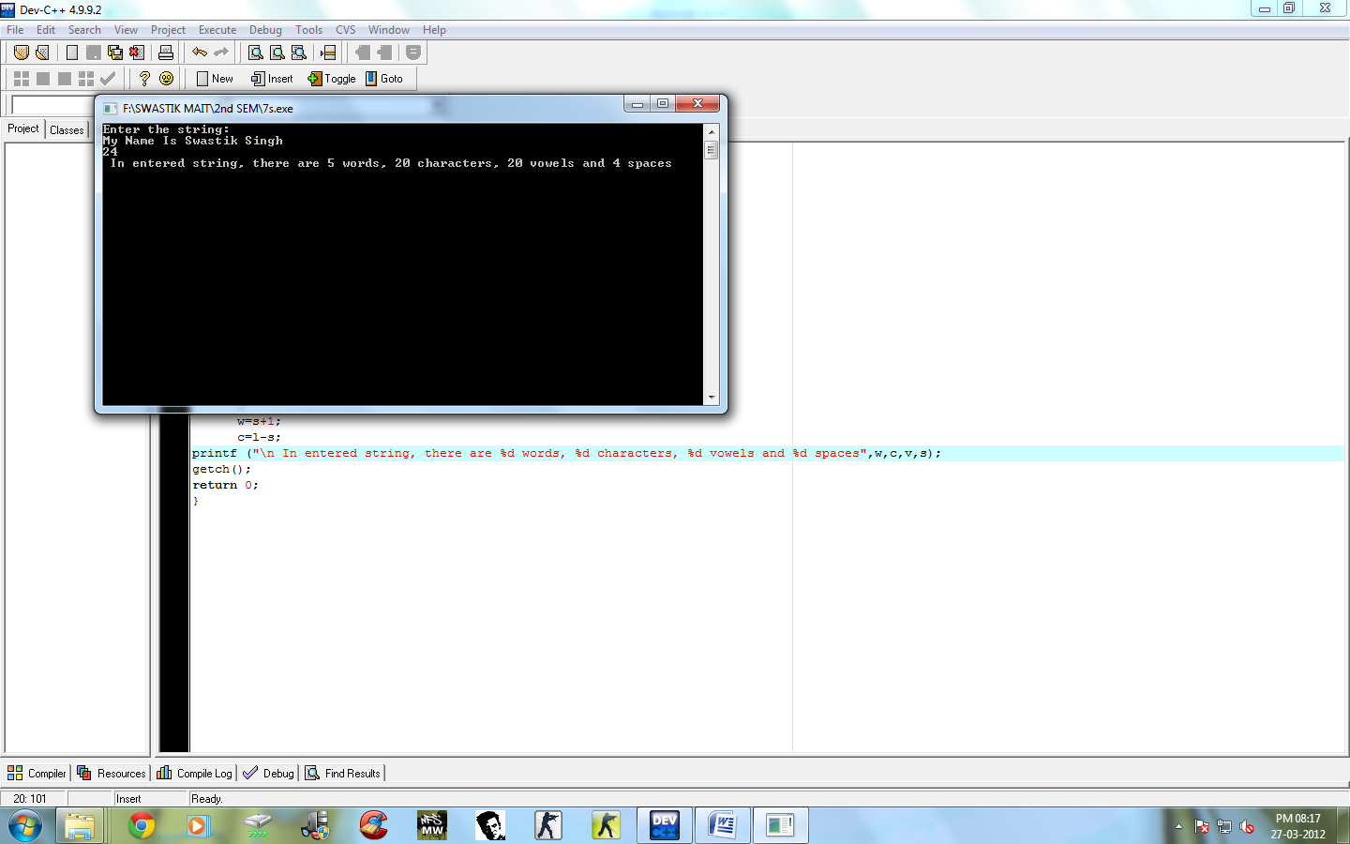
spaces",w,c,v,s);
getch();
return 0;
}

PROGRAM TO DETERMINE THE CHARACTER WHOSE FREQUENCY IS MAXIMUM IN ENTERD STRING

#include<stdio.h>
#include<conio.h>
#include<string.h>
main()
{
int f=0,i,j,max=0,l;
char str[25],ch;
printf("Enter the string:");
gets(str);
l=strlen(str);
for(i=0;i<l;i++)
{
for(j=1;j<l;j++)
{
if((str[i]==str[j])&&(str[i]!=' '))
{
f++;
}
}
if(max<f)
{
max=f;
ch=str[i];
}
f=0;
}
printf("\nIn the string, %c appears at the max frequency of %d.",ch,max);
getch();
return 0;
}

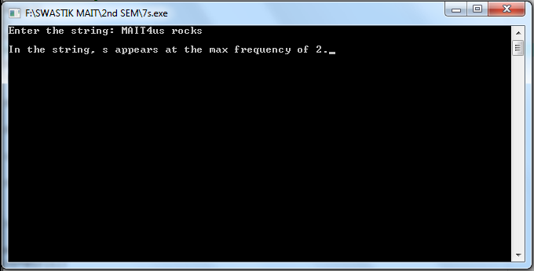

PROGRAM TO SEARCH AN ELEMENT OF AN ARRAY USING LINEAR SEARCH:

#include<stdio.h>
#include<conio.h>
main()
{
int A[50],i,x,n,c=0;
printf("enter the limit of array:");
scanf("%d",&n);
printf("enter the elements:");
for(i=0;i<n;i++)
{
scanf("%d",&A[i]);
}
printf("enter the element which should be searched for:");
scanf("%d",&x);
for(i=0;i<n;i++)
{
if(A[i]==x)
{
c++;
printf("element is present at %dth position",i+1);
}
}
if(c==0)
printf("the element is not present");

getch();
return 0;
}

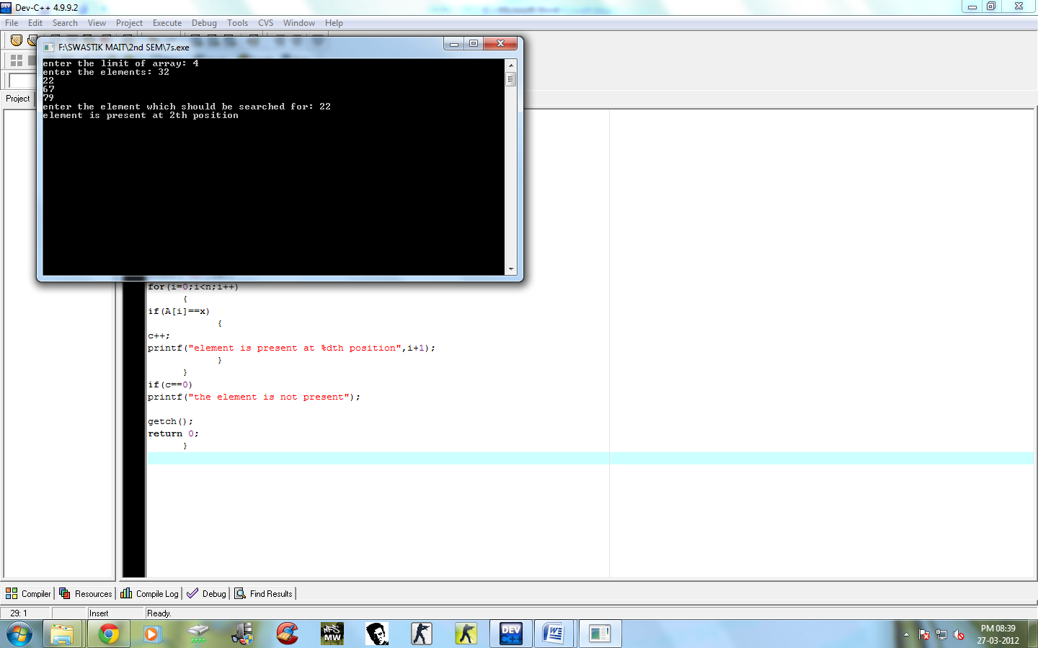

PROGRAM TO SEARCH AN ELEMENT OF AN ARRAY USING BINARY SEARCH:

#include<stdio.h>
#include<conio.h>
main()
{
int A[50],i,x,n,f=0,l=0,mid,u;
printf("enter the limit of of ascending sorted array:");
scanf("%d",&n);
printf("enter the elements :");
for(i=0;i<n;i++)
{
scanf("%d",&A[i]);
}
printf("enter the element which should be searched for:");
scanf("%d",&x);
u=n-1;
while(l<=u)
{
mid=(l+u)/2;
if(A[mid]==x)
{
f++;
printf("\nelement is present at %dth position",mid+1);
break;
}
if(A[mid]>x)
u=mid-1;
if(A[mid]<x)
l=mid+1;
}
if(f==0)
printf("the element is not present");
getch();
return 0;
}

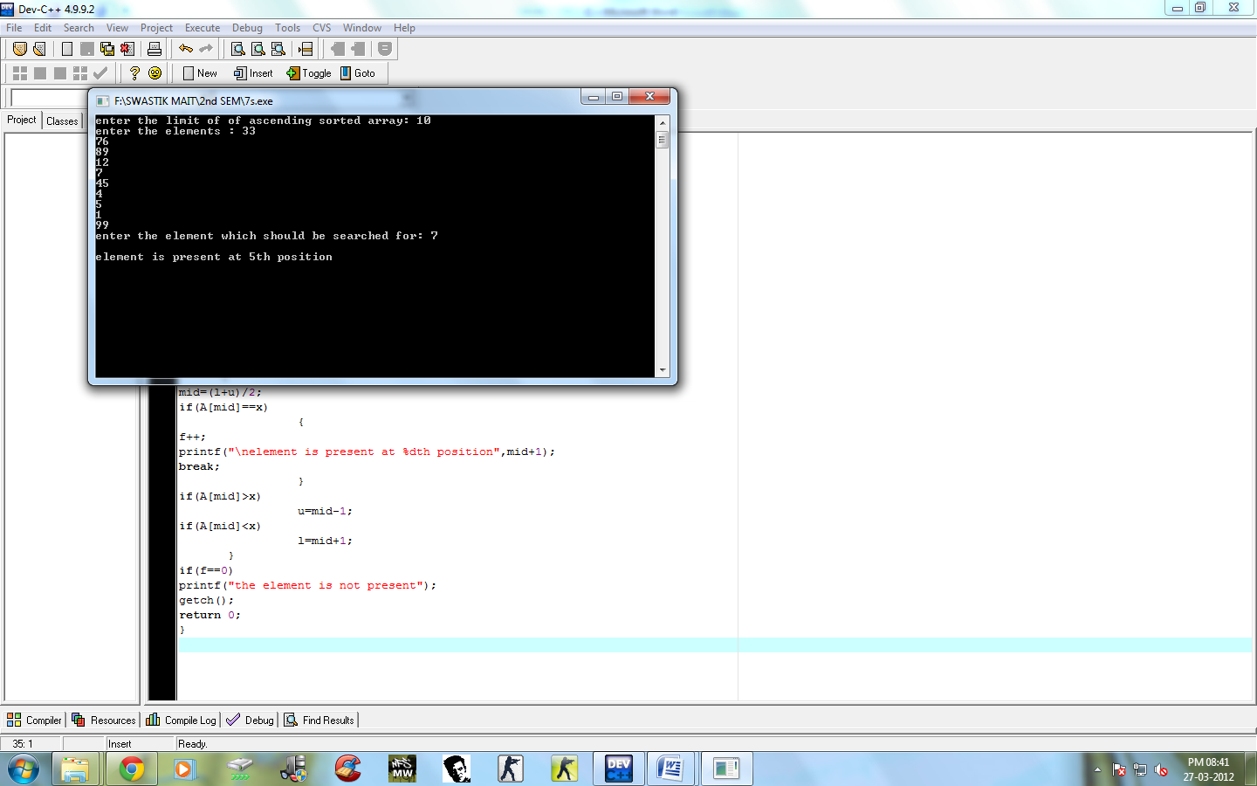

PROGRAM TO SORT AN ARRAY

#include<stdio.h>
#include<conio.h>
main()
{
Int i,j,temp,a[10];
printf("Enter the array\n");
for(i=0;i<10;i++)
{
scanf("%d",&a[i]);
}
for(i=0;i<10;i++)
{
for(j=0;j<10-i;j++)
{
if(a[j]>a[j+1])
{
temp=a[j];
a[j]=a[j+1];
a[j+1]=temp;
}
}
}
printf("\nThe array in ascending order\n");
for(i=0;i<10;i++)
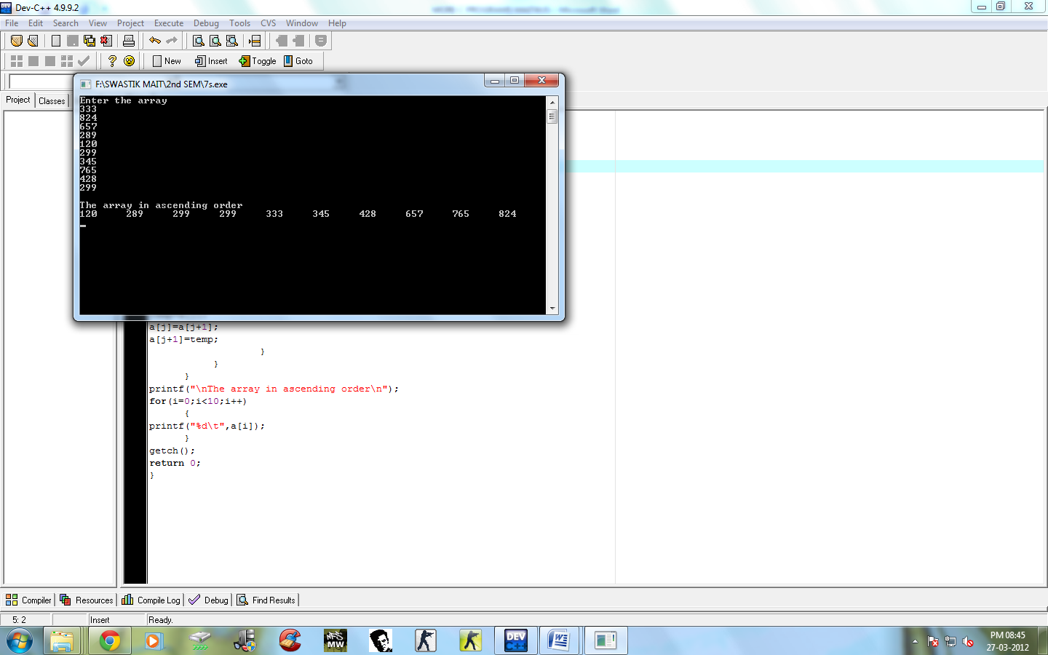
{
printf("%d\t",a[i]);
}
getch();
return 0;
}

